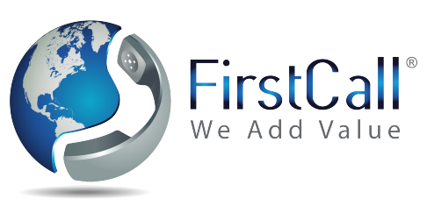
Level 2 – Live Call Handling
Call Center Operation Hours:
24/7

Start Date: | Company Name: | Account No:

 | Allocated Number:
“Good Morning/Afternoon - Company Name Ltd.  Michelle speaking how can I help you? “ | Greeting of the Live Operator:
 |  | What information do you want us to capture:
 |  | - Full Name  - Company Name  - Telephone Number  - Email Address  - Reason for calling  Email:  SMS: | 1
Department ( optional )

e.g Name: James Bond Position/Dep: Sales Email: accounts@abc.com Sms: 972XXXXXXXX
Name: |  | Position/Dep: |  | Email: |  | Sms:
Name: |  | Position/Dep: |  | Email: |  | Sms:
Name: |  | Position/Dep: |  | Email: |  | Sms:

Patching: Who are we forwarding calls to ? ( optional )

Name: |  | Position/Dep: |  | Email: |  | Phone:
Name: |  | Position/Dep: |  | Email: |  | Phone:
Name: |  | Position/Dep: |  | Email: |  | Phone:

Thank you for contacting us |  | Farewell Ending:

Your Business Information
( This information the operator will hand out if asked upon )
 | Telephone Number: |  | Company Name:
 | FAX: |  | Company Address:
 | Email: |  | Business Services:
 |  |  | Website:

 | Additional Information:
 | FAQ:

